EENG 284

–

Digital Design Lab

Lab119

–

Stopwatch Datapath and Control

Lab Solutions

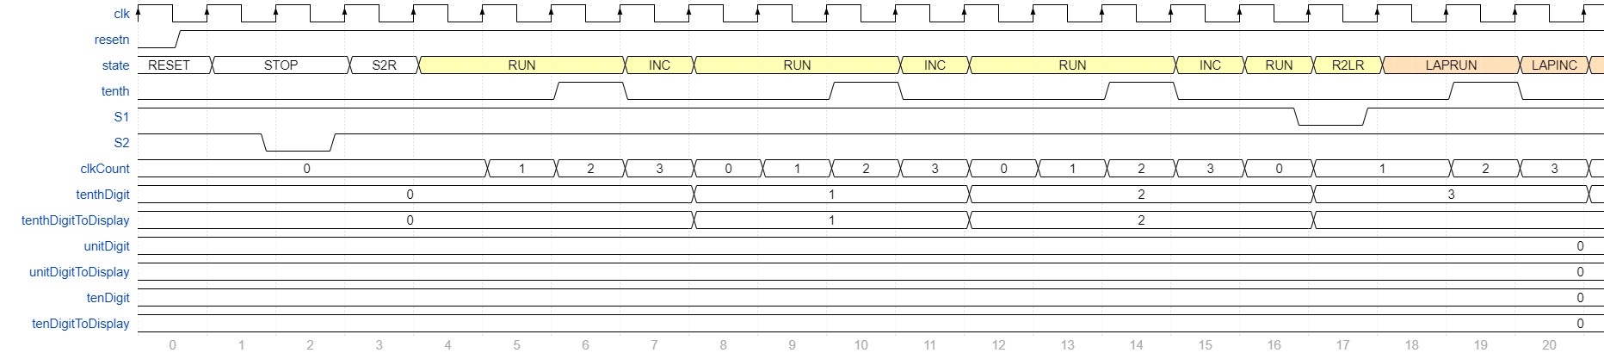

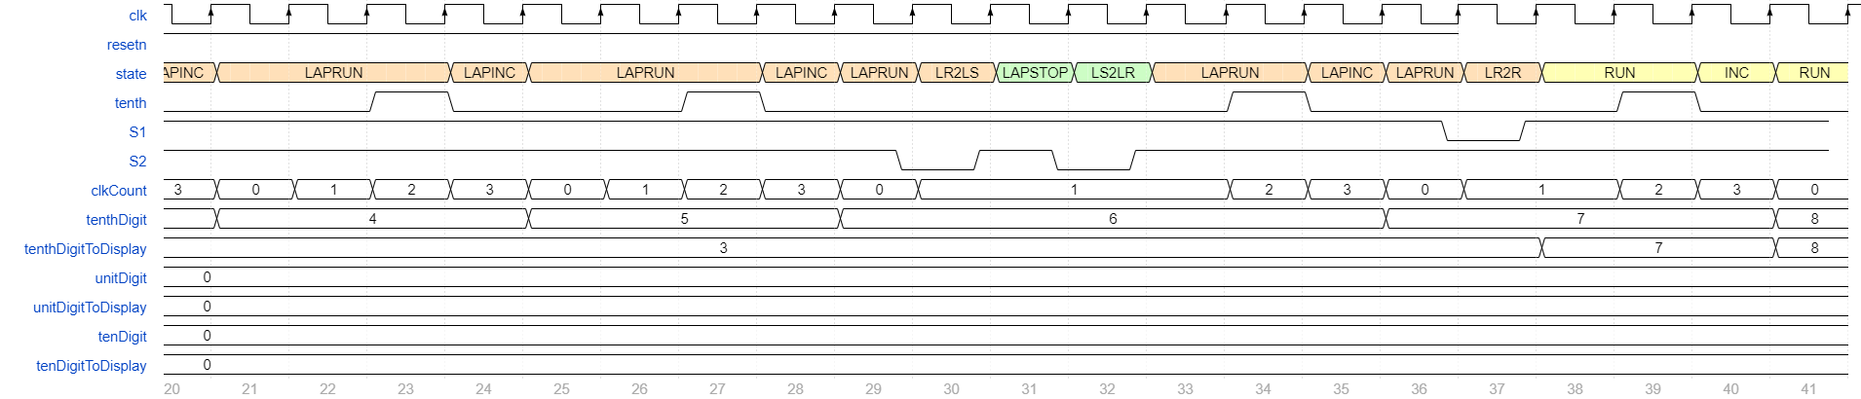

|  |  |  |  |
| --- | --- | --- | --- |
| Segment | tenHex Hex2 | unitHex Hex1 | tenthHex Hex0 |
| seg[6] | W20 | AF24 | Y18 |
| seg[5] | W21 | AC19 | Y19 |
| seg[4] | V20 | AE25 | Y20 |
| seg[3] | V22 | AE26 | W18 |
| seg[2] | U20 | AB19 | V17 |
| seg[1] | AD6 | AD26 | V18 |
| seg[0] | AD7 | AA18 | V19 |

|  |  |  |
| --- | --- | --- |
| S2 | Key[3] | Y16 |
| S1 | Key[2] | Y15 |
| resetn | Key[0] | P11 |
| clk | CLOCK_50 | R20 |

